

**A Startup Analysis - Documentation**

**INTRODUCTION**

**1.1Overview**

Start-up analysis projects refer to the process of analysing start-ups and their potential for success. Such projects typically involve conducting research, gathering data, and using various analytical tools and techniques to evaluate the viability of a start-up. The ultimate goal of a start-up analysis project is to provide insights and recommendations on the potential success of the start-up. Such analysis can be helpful for investors, accelerators, incubators, and other organizations that support start-ups. By analyzing a start-up’s strengths, weaknesses, and potential for success, stakeholders can make informed decisions about whether to invest in or support a particular start-up.

**1.2 Purpose**

The Purpose of a start-up analysis project is to gather and analyze data on the performance of start-ups in order to gain insights into their challenges, opportunities, and growth potential in data visualization. The visualization represents the Number of Startups by Industry and State and Year, Startups by Year and Applying filers of Industry and State.

**2 Problem Definition & Design Thinking**

**2.1 Empathy Map**

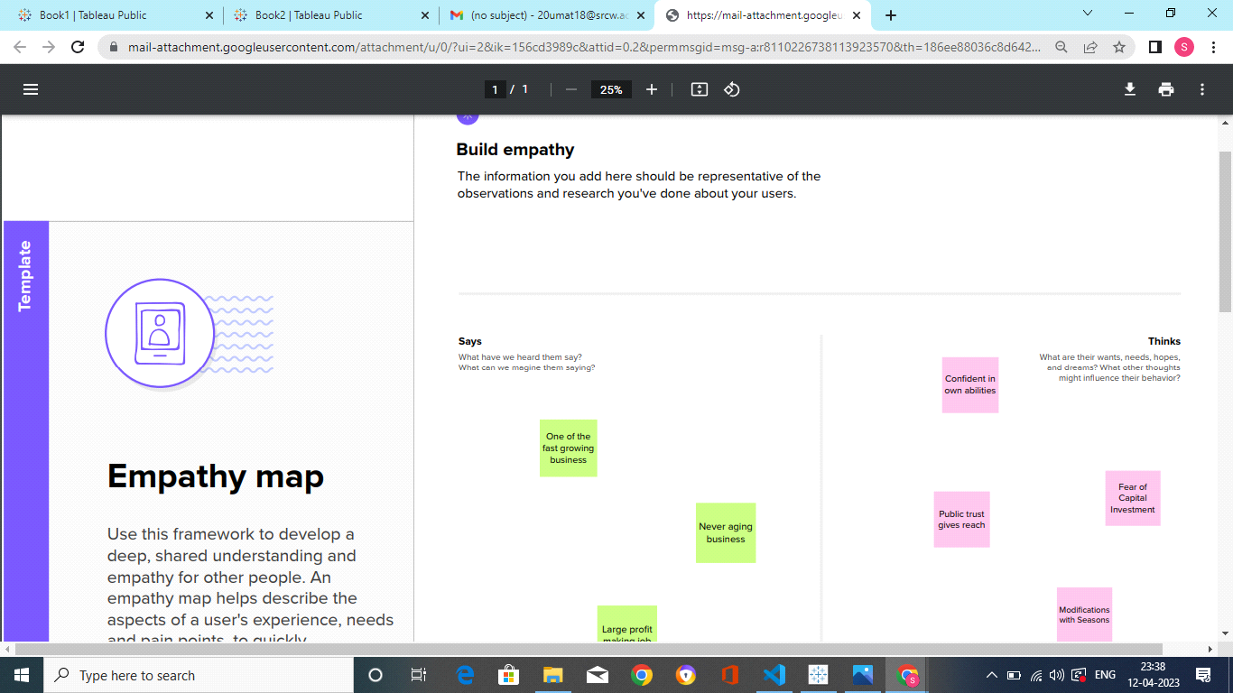

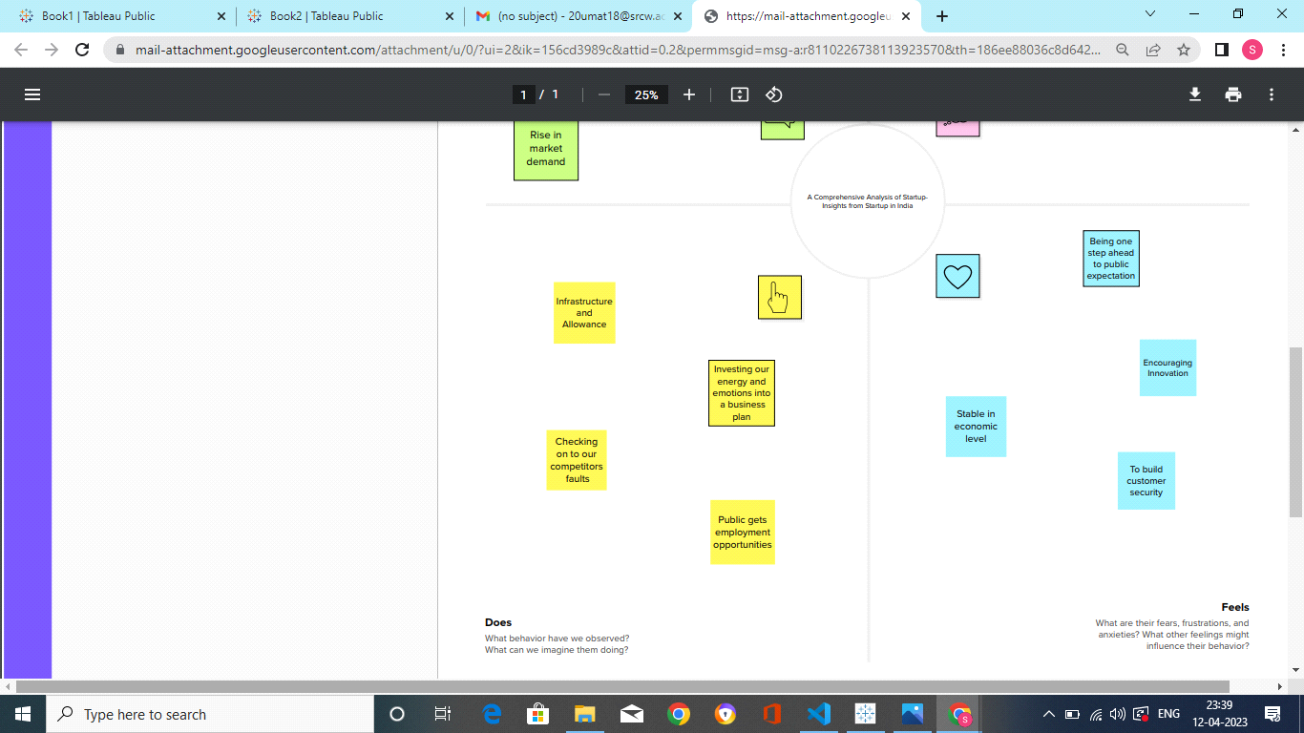

**2.2 Brainstroming & Ideation**

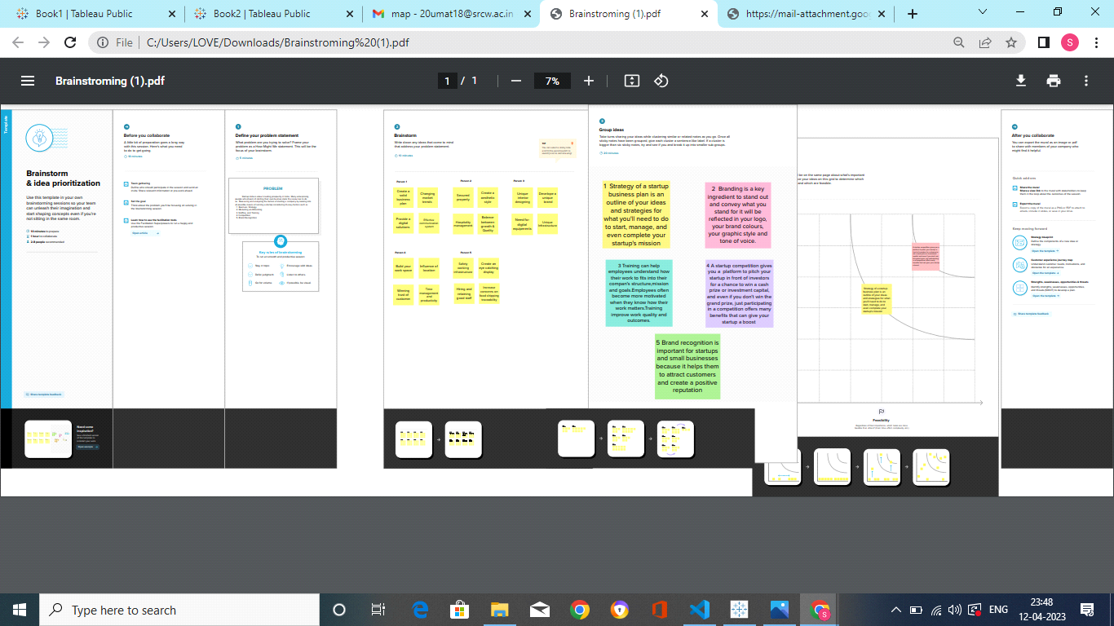

**3 RESULT**

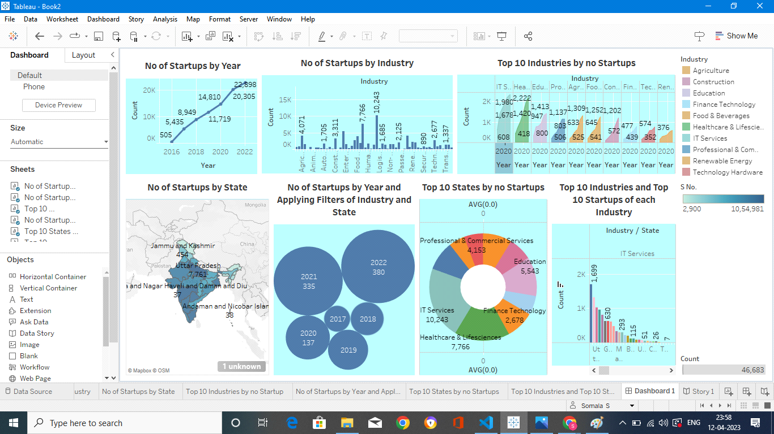

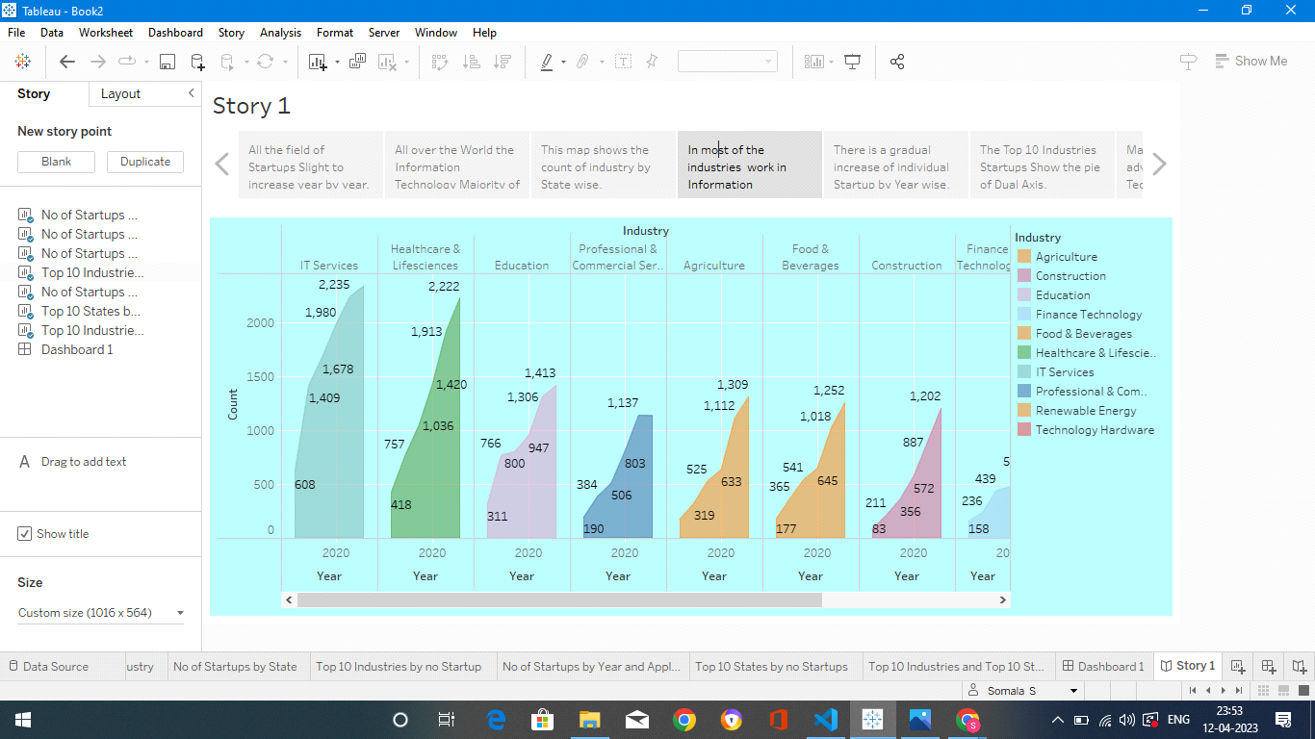

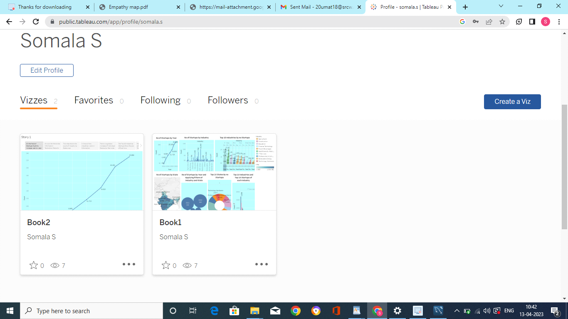

**4 ADVANTAGES AND DISADVANTAGES**

**Advantages:**

1 Comprehensive data: Comprehensive data on the Indian startup ecosystem, including information on funding, exits, and growth rates

2 Data-driven insights: Insights can be used to benchmark startups, identify areas for improvement, and learn from successful startups.

3 Academic Research: Academic researchers studying entrepreneurship, innovation, and technology in India.

**Disadvantages**

1 Incomplete data: Lead to incomplete or inaccurate analyses of the startup ecosystem.

**2** Limited scope: Focusing only on certain industries or stages of startup development

3 Data quality issues: The accuracy and reliability of the data used in the project may be limited by data quality issues.

4 Lagging data: Identifying emerging trends and opportunities.

**5. APPLICATIONS**

1 Industry Analysis: Analyze trends and opportunities, such as

e-commerce, fintech, and health tech.

2 Startup Identification: Business model, funding history, growth rate, team size, and revenue.

3 Entrepreneurial Education: Provide students with the knowledge, skills and motivation to encourage entrepreneurial success.

4 Academic Research on entrepreneurship, innovation, and technology in India.

**6 CONCLUSION**

Thus we have developed our project collaboratively working on the key factor of gaining insights into the growth potential by visualising our data. We analysed a startup's strengths, weaknesses, potentials, and stakeholders and developed a project which is useful for investors, accelerators, incubators and organisations working closely with promoting startups than traditional reporting.  
  
**7 FUTURE SCOPE**

 The data set used here lacks insights into private startups and innovative startups developed in the immediate past. More surveys on the new methods and gig economy introduced can give a piece of more accurate and valuable information to the project developed